**Unit 1 Laboratory Skills Review Worksheet Name: _______________________**

**Match each of these vocabulary words with its definition below. Copy the definition next to the word to create a study guide for yourself. (12 x 1pt)**

Accuracy

Precision

Scientific notation

Mantissa

Significant figures

Density

Dimensional analysis

Conversion factor

Equivalence statement

Quantitative

Qualitative

Independent variable

Dependent variable

Hypothesis

Control

Theory

Law

Matter

Average

Range

Percent error

Erlenmeyer flask

Graduated cylinder

Meniscus

Systematic Error

Random Error

Mole

Anything that has mass and takes up space.

The variable that is changed or controlled in a scientific experiment. Plotted on the x-axis of a graph.

The ratio of the mass of a substance to the volume of the substance.

The difference between the maximum and minimum values in a data set.

A summary of many experimental results and observations that tells how things work.

Errors (in either direction) in measured data due to the limitations of the measurement device.

A well-substantiated explanation of some aspect of the natural world, based on a body of facts that have been repeatedly confirmed through observation and experiment.

The variable being tested and measured in a scientific experiment. Plotted on the y-axis of a graph.

Errors in data that are consistently in the same direction. Due to procedures or equipment used.

The numerical portion of a number in scientific notation that contains any and all significant digits.

The closeness of a measurement to the true value.

A cylindrical piece of glassware with a scale used for measuring liquids.

A number that is derived from and considered typical or representative of a set of numbers.

A mathematical tool for converting between units of measurement that is equal to 1.

A calculation expressing the typical value in a set of data.

A simple equation showing how two units are related numerically.

The closeness of agreement among a set of results.

A unit representing 6.022 x 1023 items often used to count atoms.

A theory or explanation that is based on observations and that can be tested.

Data marked by the descriptive character of something rather than its numerical measurement.

A calculation measuring how close an experimental value is to a known true value.

The curved surface of a liquid in a graduated cylinder.

A measure of how close an experimental result is to an accepted or know value.

A case designed to check the results of an experiment by setting the independent variable to zero.

A piece of laboratory glassware with sloping sides and a narrow neck used for transferring liquids.

Data marked by numerical measurements collected by using laboratory equipment.

The digits in a number that carry meaning contributing to its measurement resolution.

A method for converting units that uses conversion factors.

A number format used for expressing very large or very small quantities.

**2. Identify the following Laboratory Equipment (3 x 1pt) Any item on the image of lab equipment or located in the classroom is fair game.**

[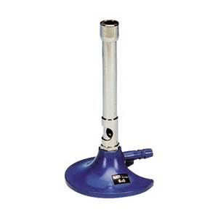](http://www.bing.com/images/search?q=bunsen+burner+image&view=detailv2&adlt=strict&id=F25980F4E2C67E2761360380D422055540A3EC2A&selectedIndex=2&ccid=9vR/y62M&simid=608051423319885653&thid=OIP.Mf6f47fcbad8c4b45018369b651a30864H0)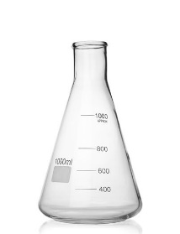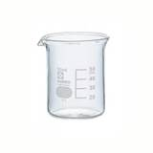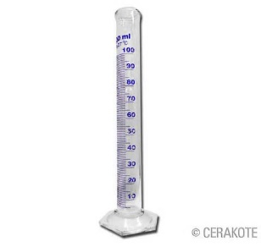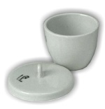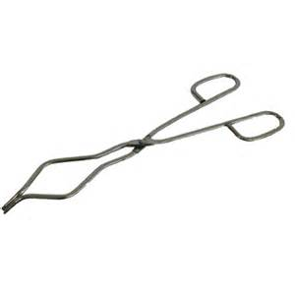

**3. Measurement (2 x 3pts) Measure the following items to the proper number of significant figures using the scales provided. Remember to estimate in between the smallest gradations on any scale. On the test you may have a real graduated cylinder to read, or a mass to weigh using a triple beam balance, or a physical object to measure, or an image to measure or read like below.**

[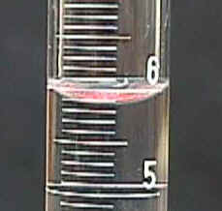](http://www.ugr.es/~jperez/docencia/Evolver/tutorial6.html) a) mL b) Measure length in cm using a standard ruler.

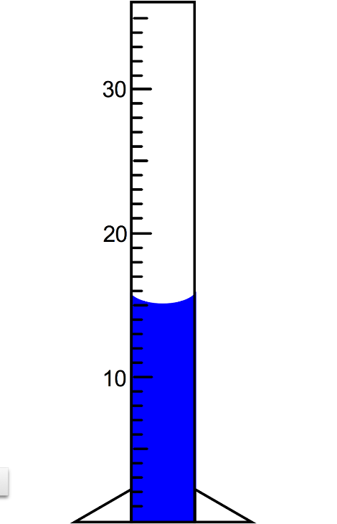d)

mL

c)

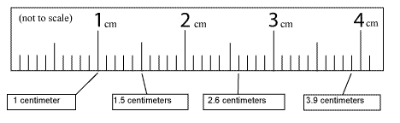

**4. Convert between Scientific Notation and Standard Notation (4 x 2 pts)**

* 1. 0.00000978 L ______________
  2. 837,100,000 cm3 ______________
  3. 0.005930 g ______________
  4. 6.130 x 10-9 m ______________
  5. 1.2552 x 107 J ______________
  6. 1.05 x 109 Hz ______________

**5. Identify number of Significant figures present in each number (4 x 2pts)**

a. 0.000450 cm _____

b. 3.5 x 103 kg _____

c. 60,700 hours _____

d. 350 m _____

e. 0.0030 sec _____

f. 1.00 x 103 mL _____

**6. Round to the given number of sigfig. Express in scientific notation if you need to use more than 3 zeros. (2 x 2pts)**

a. 9,837,420,058 to 4 sigfigs __________________

b. 0.0003890026 to 4 sigfigs __________________

c. 509,800,528,620 to 3 sigfigs __________________

d. 52.8905 to 3 decimal places __________________

**7. Add or Subtract, give answer in correct # of sigfigs. (4 x 2 pts) – mixed with Mult/Div**

a. 3750 g + 42 g ___________________

b. 33.604 cm – 17.2 cm ___________________

c. 2.71 x 10-4 s – 4.36 x 10-5 s ___________________

d. 2.81 x 104 m + 4.8 x 102 m ___________________

**8. Multiply or Divide, give answer in correct # of sigfigs. (4 x 2 pts) – mixed with Add/Sub**

a. (12.05 m)(0.041 m)(2.53 m) ___________________

b. $\frac{28.75 g}{14.0 mL}$

___________________

c. $\frac{8.20 × {10}^{-3}g}{1.531 ×{10}^{-2} s}$

___________________

d. (2.4 x 103 cm)(1.58 x 101 cm)(4 x 103 cm) ___________________

9. Perform the following metric conversions using any method you prefer. Show your work. (3 x 2pts)

a. 350 g to mg

b. 0.000430 s to μs

c. 40,5000,000 mL to kL

d. 0.00207 m2 to cm2

e. 3.6 x 10-8 mg to ng

10. Perform the following conversions using dimensional analysis. (Factor label method.) Show your work. (2 x 4 pts)

a. 13.5 mL to L

b. 153 km to cm

c. 3.50 years to sec

**11. Solve these density problems: (3 x 3 pts)**

a. A 5.75 g object is submerged in 22.5 mL of water is raising the water level to 24.1 mL What is the density of this object?

b. What volume does an iron iron have if its mass is 2.35 kg? (The density of iron is 7.86 g/cm3.)

c. What is the mass of a 350 cm3  ingot of copper? (The density of copper is 8.96 g/cm3.)